**INITIALIZE $Q_{t}(a)$** for all values in Q-value table # Unbiased or biased w/ prior

**INITIALIZE $t= 0 , F=0$** # Time and convergence counter

**SET** hyper-parameter $z , F_{conv} ,{ ∆Q}_{conv}$# Exploration and convergence

**FOR** iterations in budget $B$***:*** # Number times we probe user

**INCREMENT $t= t + 1$**  # Increment time step counter

**CALCULATE** uncertainty for each action $U_{t}\left(a\right)=z∙\sqrt{\frac{2log(t)}{N_{t}(a)}}$# See Equation 1

**SELECT** action with max value $a_{t}$ = $\underset{a A}{arg max}\left(Q_{t}\left(a\right) + U_{t}\left(a\right)\right)$# See Equation 2

**INCREMENT $N_{t}\left(a\right)= N_{t}(a) + 1$** # Increment action a counter

**EXECUTE** action $a_{t}$# Present sound to user

**PROBE**  user for feedback $S_{infer}$ and $C$# Ask users two questions

**CALCULATE** reward signal $R= S_{check}∙C$# See Equation 3

**UPDATE $Q_{t+1}\left(a\right)=\left[\left(1 - \frac{1}{n}\right)∙ Q_{t}(a)\right] + \left[\frac{1}{n} * R\right]$**  # See Equation 4

**CALCULATE $∆Q=Q_{t+1}\left(a\right) {- Q}_{t}(a)$** # See Equation 5

**IF $S_{infer}= S_{real } and \left[\left({a_{t}=a}_{t-1}\right) or \left(∆Q≤{ ∆Q}_{conv}\right)\right]:$**  # See Equation 6

$F=F + 1$

**ELSE**  **:**

$F=0$

**IF $F{≥F}_{conv}$:** # Check if the state has reached convergence

**BREAK**

**END** loop



Agent

Observation of state $S$

Reward $R$

Action $A$



Environment

Initialize Q-value table and hyper-parameters

Present sound $a_{t}$ to user and probe user for feedback $\hat{S}$ and $C$

Calculate uncertainty $U_{t}\left(a\right)$ for each action

Select sound $a_{t}$ using $\underset{a A}{arg max}\left(Q_{t}\left(a\right)+U_{t}\left(a\right)\right)$

Terminate

Calculate change in $Q$

$$∆Q=Q_{t+1}\left(a\right) {- Q}_{t}(a)$$

Calculate reward $R$ andupdate Q-value table with $Q_{t+1}\left(a\right)$

Increment budget $B$

Increment timestep $t$

NO

YES

Remaining budget $B$?

Converged?

NO

YES

Check for convergence using $∆Q$

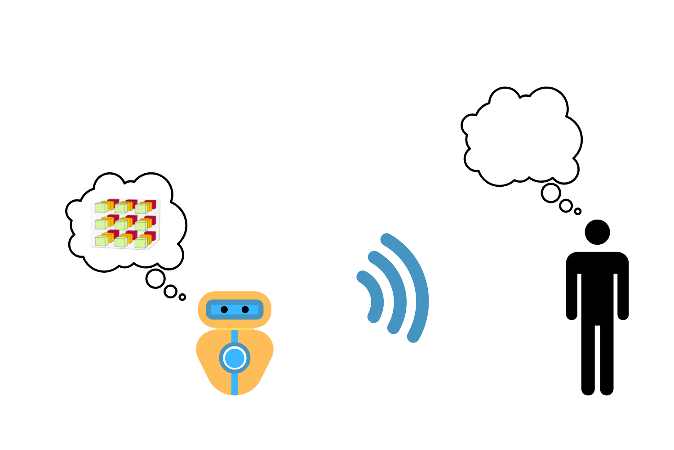

2

Robot generates nonverbal expression to communicate values to express its state $S$

1

Robot selects $n$ parameters and values to express its state $S$

3